Overall structure:

* Two separate pages:
  + Explanation page
  + Camera activity page

How digital sensors work:

* 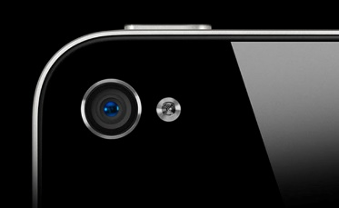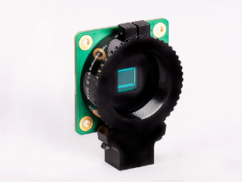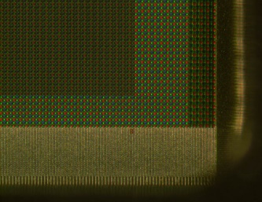
* In a film camera, light is projected onto photographic film by a lens, creating an image of the scene. But how does a digital camera sensor work?
* Digital camera sensors consist of arrays of tiny light-sensitive “photosites” referred to as pixels. As light hits a pixel, an electrical signal is generated which can be read off by the camera’s processor. A larger signal is registered if there is a higher intensity of light hitting each photosite, which allows us to estimate the number of photons hitting each area of the camera and decide how light or dark each area of the image should be.
* When the signal is saved in an image format such as JPEG, the brightness of the pixel is recorded as a number between 0 and 255, which corresponds to an 8 bit image. Higher values are lighter, and lower values are darker.
* But this only gives us black and white images. If we look at this picture of a CMOS sensor, we can see that each pixel is actually a different colour – there’s Red, Green and Blue pixels.
* This is called a bayer filter – a repeating checker-board like array of colour filters which sits over the pixels. Before processing, bayer images actually look quite weird. Each pixel only takes in red, green or blue light, which results in a kind of checkerboard over the image. The chip then combines these colours into a full colour 3 layer stack.
* 
* Notice how the Bayer array contains twice as many green as red or blue sensors? The human eye is more sensitive to green light than both red and blue light, so there are double the number of green pixels to emulate the way the eye sees colour. Redundancy with green pixels produces an image which appears less noisy and has finer detail than could be accomplished if each colour were treated equally. This also explains why noise in the green channel is much less than for the other two primary colours
* Check out the image of the grafitti below. If we can split the image into the blue and red channels to see its different components!
* 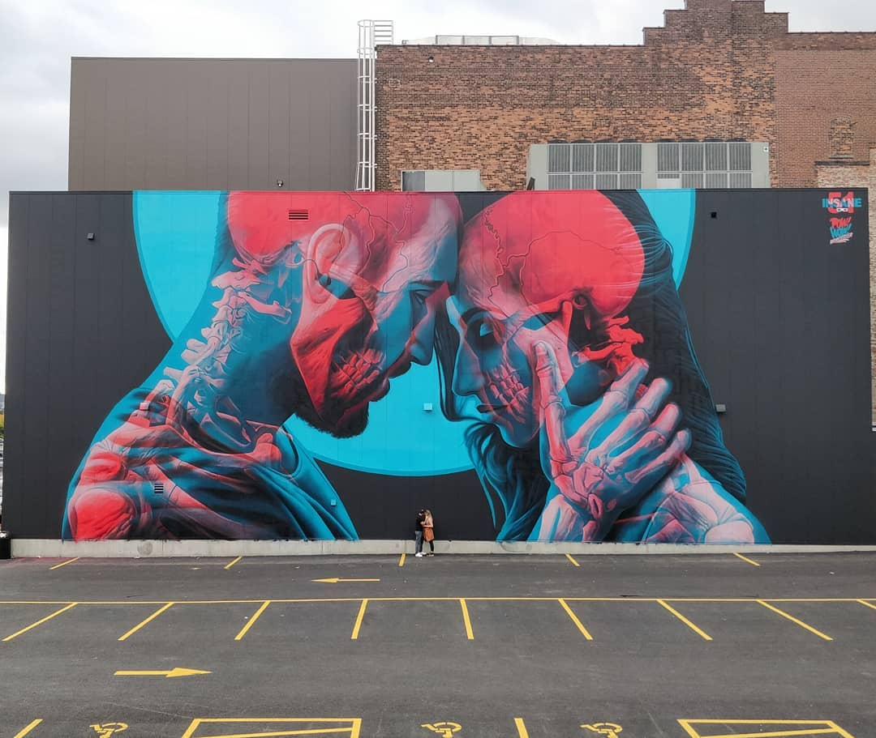

**Lab activity:**

* Camera filter which splits out colours
* Use camera to image an infrared LED from a remote control. Why does this work? Absorption spectrum